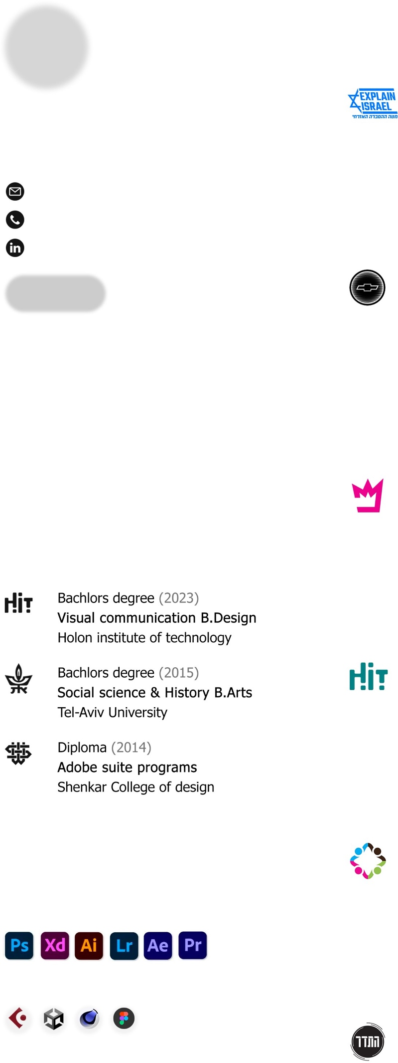

Work Experience

Video Production Lead (Oct 2023 - volunteer position)
Israeli Spirit - Tel Aviv IL

Team lead – Advocacy content for social media platforms.
• Managing video editing projects from start to finish.
• Participation in creative meetings for idea pitching.
• Data report of content trends & insights to improve outcome.

Creative Producer (2022 - current position)
Reshet Kehila - Holon IL

Social Graphic designer & Post production.
• Concept development & creating visual identity for events.
• Held in charge of marketing and promotions.
• Post-Event content : post production of videos & socials.
• Maintaining clear communication with teams & clients.

Visual art intern (summer of 2022)
Rimon studio BETA group - Tel aviv IL

Assisted in a variety of developed apps & interactive projects.
• Concept & visual improvement for educational games.
• Video and post-production.
• UX/UI research presentations.

Teacher (2020 - 2022)
H.I.T Institute of Technology - Holon IL

Classroom support for Webflow & Figma courses.
• Technical support: teach interface navigation & web tools.
• Instructional support of design tools & UX UI features.
• Provide private assistance to students.

Graphic designer (summer of 2020 - volunteer position)
Matzmichim center - Petach Tikva IL

Designer of digital marketing campaigns & socials.
• Posters, pamphlets & catalogues design.
• Team work חס different missions.
• Concept & visual design for advertisements.

Youth Instructor (2019 - 2022)
Rishon Lezion Municipality - Rishon Lezion IL

Mentor of youth volunteers in music productions & live events.
• Effective lessons on lighting & sound design.
• Encourage critical thinking & problem-solving skills.
• Group discussions, activities, & interactive experiences.

Tamir Hausman
Creative Designer

tamirhausmann@gmail.com 050-3300146
Linkedin

Portfolio

Designer with a passion for motion graphics & visual productions. Looking for a full time position, an interesting environment & good vibes. I Love 3D modeling, video vfx , 2D animation & creating visually appealing products.

Education

Bachelor’s degree (2023)
Visual communication B.Design Holon institute of technology

Bachelor’s degree (2015)
Social science & History B.Arts Tel-Aviv University

Diploma (2014)
Adobe suite programs Shenkar College of design

Programs

Adobe Programs (Proficient)

Sound & Creative Programs (Proficient)

Languages

Hebrew - Native English - Proficient German – Basic

